BOT-BRAIN: AN INTELLIGENT STUDENT CAMPUS NAVIGATOR - DESIGN REPORT

ABSTRACT
This project aims to develop Bot-Brain, an intelligent agent that assists students in navigating the Chanakya University campus. The system considers the campus as a graph structure with more than 12 locations and uses AI search algorithms (BFS, DFS, UCS, and A*) for route finding via text chatbot navigation. It also provides building information such as facilities and timings and compares the algorithm’s efficiency for further improvements.

INTRODUCTION
Navigating a large campus like Chanakya University can be challenging especially to new students and visitors. Bot-Brain offers an \ navigation assistant that provides directions and building details to solve this problem. The project uses graph theory and search algorithms to solve the navigation problem.
PROBLEM STATEMENT
Students find it hard to locate university buildings, facilities, and offices. As a result, they waste a lot of time trying to find their way since there is no AI-based navigation system that can guide them. Bot-Brain aims to assist students by providing a digital tool for campus navigation, data retrieval, and intelligent query processing.
OBJECTIVES
- Create a graph-based model for the Chanakya University Campus with at least 12 significant locations.
- Implement the pathfinding algorithms: BFS, DFS, UCS, and A*.
- Develop a chatbot tool for inquiry.
- Give building details (hours, amenities, services).
- Compare search algorithms based on distance and node efficiency.
SCOPE
The project aims to assist users in navigating and obtaining information about Chanakya University campus. Users can input queries such as “Find path from Hostel to Library” and obtain text-based output. Advanced features like GPS tracking and voice assistance are not included but can be considered for product evolvement.

SYSTEM ARCHITECTURE
Bot-Brain follows a modular architecture:
- User Input: Queries (e.g., "Find path from Hostel to Library") are entered via a chatbot or UI.
- Bot Interface: Processes the query and forwards it to the NLP & Bot Engine.
- NLP & Bot Engine: Interprets intent (navigation or information) using natural language processing.
- Database: Supplies building details, timings, FAQs, and path data.
- Navigation/Map API: Applies BFS, DFS, UCS, or A* to find the optimal path.
- Output: Displays the shortest route, distance, walking time, and building info.

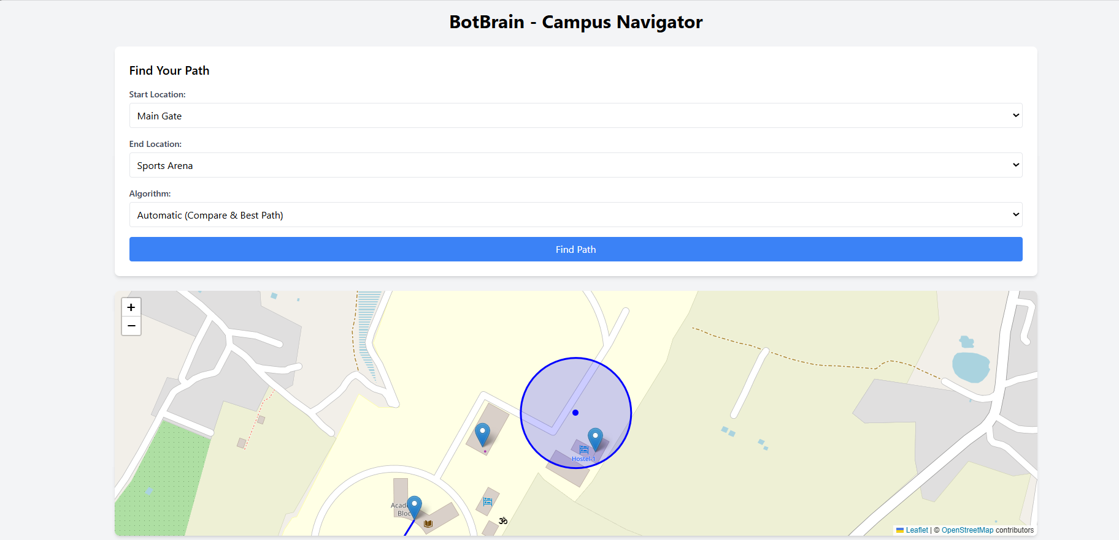

MODULES AND FEATURES
1) User Interface: A web-based GUI with dropdowns for start/end locations and algorithm selection (BFS, DFS, UCS, A*, Automatic).
Displays the route, distance, walking time, and highlights the path on a map using Leaflet.
Provides location details on demand.
2) NLP & Bot Engine: Processes natural language queries (e.g., "Show me path from Hostel to Library"). Identifies navigation vs. information requests.
3) Navigation/Pathfinding Module: Implements BFS, DFS, UCS, and A* using a graph representation.
Calculates shortest paths, distances, and walking times, with A* using Euclidean distance as a heuristic.
4) Database Module: Stores building data (name, timings, services) and path data (start node, end node, distance).
Supports FAQs and staff information for query responses.

DATABASE SCHEMA DESIGN
1) Buildings Table
Building-ID: Integer
Name: Text (e.g., "Library")
Type: Text (e.g., "Academic")
Opening-Hours: Text (e.g., "8 AM - 10 PM")
Services: Text (e.g., "Study halls, Wi-Fi")
2) Paths Table
Path ID: Integer
Start Node: Text (e.g., "Hostel")
End Node: Text (e.g., "Library")
Distance: Integer (e.g., 350)
Path Type: Text (e.g., "Two-way")
3) Staff Table
Staff ID: Integer
Name: Text
Department: Text
Office Location: Text
4) FAQ Table
FAQID: Integer
Question: Text (e.g., "What are library hours?")
Answer: Text (e.g., "8 AM - 10 PM")

METHODOLOGY
Bot-Brain operates on the Perceive → Think → Act cycle:
- User Input: Students enter queries via the interface.
- Processing: The Bot Engine interprets the query using NLP, deciding between navigation or information retrieval.
- Execution: For navigation, applies BFS/DFS/UCS/A* on the campus graph; for information, fetches data from the database.
- Output: Returns the path (with distance and time) or building details.

CAMPUS ENVIRONMENT MODELING
- Campus Representation: The campus is modeled as a graph with 16 nodes (exceeding the minimum 12): Main Gate, Admin Block, Library, Auditorium, Academic Block B, Food Court, Laundry, Faculty Hostel, Hostel, Sports Complex, Football Ground, Cricket Ground, Basketball Court, Volleyball Court, Tennis Court, Cafe. Edges represent paths with weighted distances (e.g., Main Gate to Admin Block: 160m). Constraints include one-way paths (e.g., certain campus roads) and varying walking speeds (assumed uniform for simplicity).

- Graph Representation: A hand-drawn map (refer to image1.jpg) illustrates nodes and edges, with distances labeled in meters. Coordinates are provided for A* heuristic implementation (e.g., Main Gate: [13.2213517, 77.7551040]).

SEARCH ALGORITHM IMPLEMENTATION
- BFS: Uses a queue to explore all nodes level by level, ensuring the shortest path.
- DFS: Uses a stack for depth-first exploration, potentially finding longer paths.
- UCS: Uses a priority queue based on cost, ensuring the shortest path by distance.
- A*: Enhances UCS with a Euclidean distance heuristic for optimal pathfinding.
Each algorithm displays step-by-step node exploration (e.g., Main Gate → Connecting Point → ...).

ALGORITHM COMPARISON
The "Automatic" mode compares BFS, DFS, UCS, and A* for each query, displaying:

- Distance (meters): Walking time (minutes, assuming 4 km/h)
- Nodes explored: The best algorithm is selected based on the shortest distance.

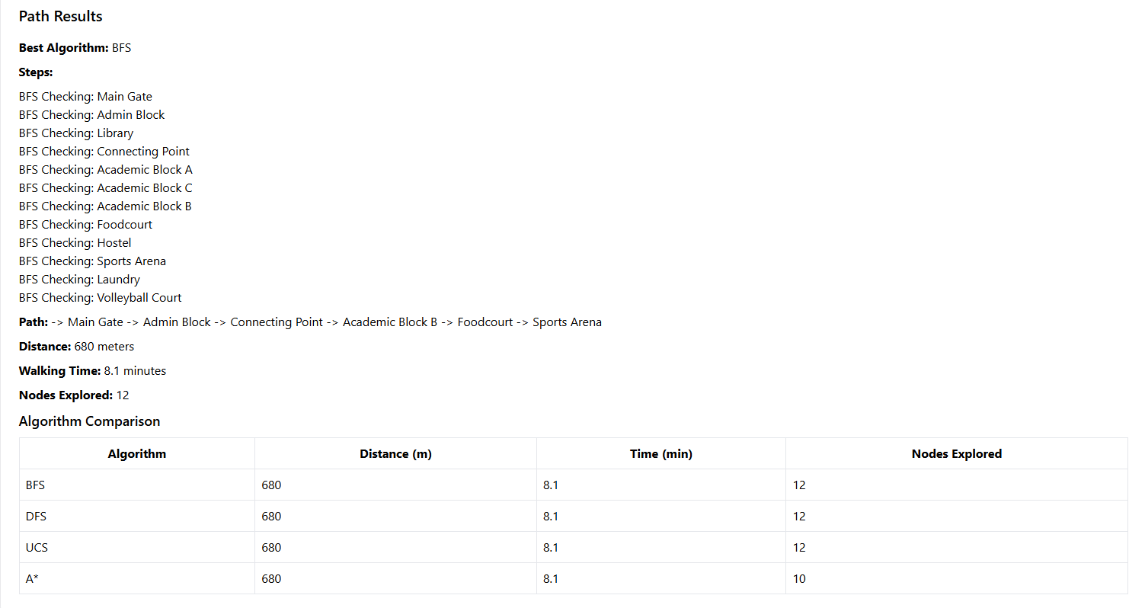

AGENT DESIGN
Agent Type: Goal-based, aiming to find the shortest path or retrieve information.

PEAS DESCRIPTION
- Performance: Shortest path distance, query response time.
- Environment: Chanakya University campus (static graph).
- Actuators: Display path and building info on the UI.
- Sensors: User input via text or dropdowns.

IMPLEMENTATION DETAILS
- Programming: HTML, JavaScript (with Leaflet for maps), and a Python backend.
- Tools: Tailwind CSS for styling, OpenStreetMap for map data.
- Code: Available on GitHub with detailed README and comments.

Testing and Validation

Test cases include:

BFS, DFS, UCS, A* on pairs like (Main Gate → Hostel, Hostel → Library).
Chatbot queries (e.g., "find path from Hostel to Library").
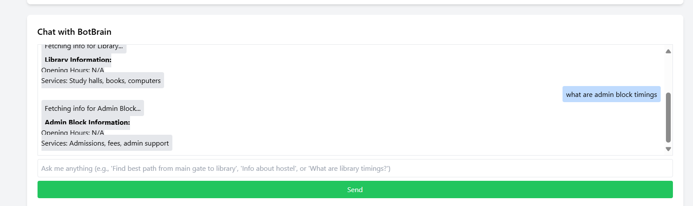
Edge cases (same start/end, unreachable locations).
Results validated against expected distances and node counts.

Conclusion

Bot-Brain successfully implements an intelligent navigation system for Chanakya University, meeting all core requirements. Future work could include GPS integration and voice support.

